Cryptography Experiment Report – Task 6
Operating System: Kali Linux
Tool Used: OpenSSL

1. Introduction
Cryptography is the foundation of modern cybersecurity. It helps protect data from unauthorized access and ensures confidentiality, integrity, and authenticity.
In this task, basic cryptographic concepts such as encryption, hashing, and digital signatures were explored using OpenSSL on Kali Linux.

2. Objectives
- Understand symmetric and asymmetric encryption
- Encrypt and decrypt files using AES
- Generate RSA public and private keys
- Hash files and verify integrity
- Create and verify digital signatures
- Learn real-world applications of cryptography

3. Tools Used
- Kali Linux
- OpenSSL (command-line cryptographic tool)

4. Symmetric Encryption (AES)
Symmetric encryption uses the same secret key for both encryption and decryption.
AES-256-CBC was used with PBKDF2 key derivation to improve security.

Encryption Command
openssl enc -aes-256-cbc -salt -pbkdf2 -iter 100000 \
-in secret.txt -out secret.enc
📸 Screenshot:
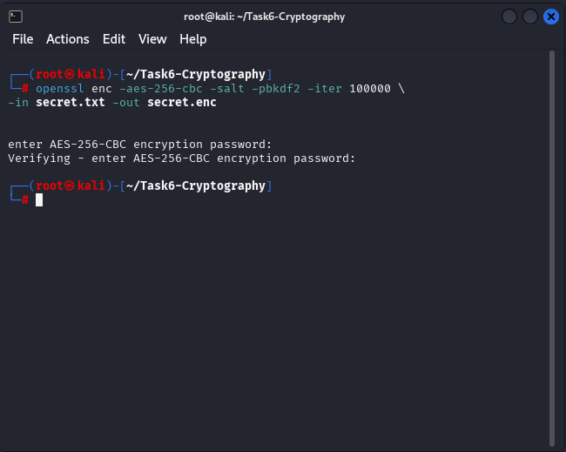
aes-encryption-pbkdf2.png

Decryption Command
openssl enc -aes-256-cbc -d -pbkdf2 -iter 100000 \
-in secret.enc -out decrypted.txt
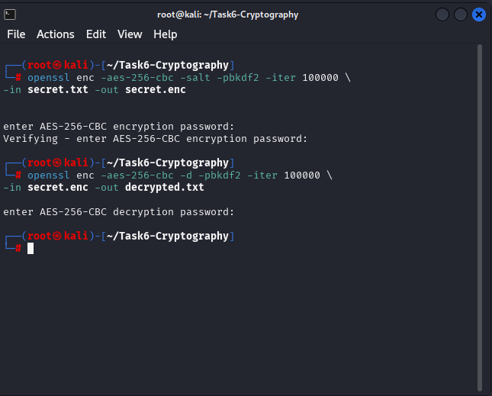
aes-decryption-pbkdf2.png
This confirms that the same password is required to encrypt and decrypt the data.

5. Asymmetric Encryption (RSA)
Asymmetric encryption uses a key pair:
- Public key (shared)
- Private key (kept secret)

Generate Private Key
openssl genrsa -out private.pem 2048
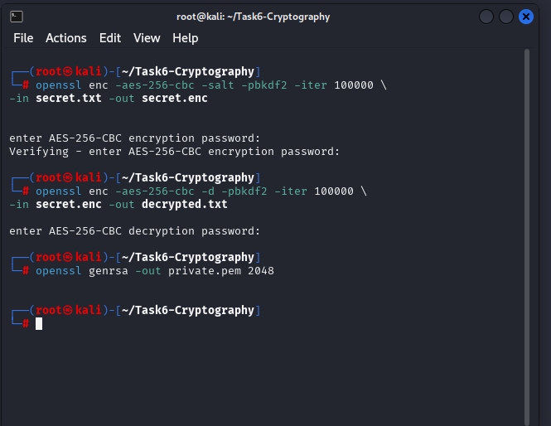
rsa-private-key.png
Generate Public Key
openssl rsa -in private.pem -pubout -o ut public.pem

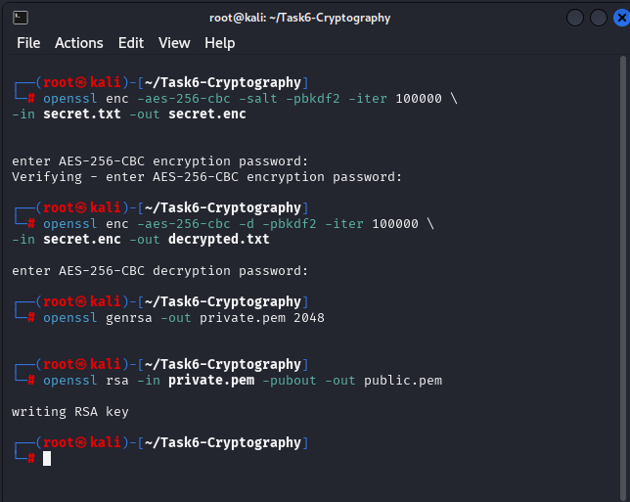 rsa-public-key.png
RSA is commonly used for secure key exchange and authentication.

6. Hashing & Integrity Verification
Hashing converts data into a fixed-length value used to verify integrity.

SHA-256 Hash Generation
openssl dgst -sha256 secret.txt
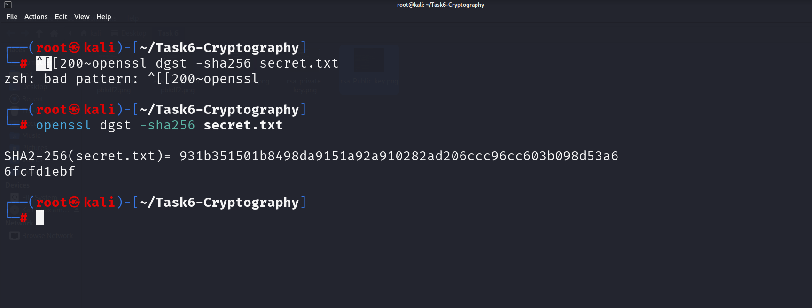
sha256-hash.png
After modifying the file slightly, the hash value changed completely, proving integrity checking.
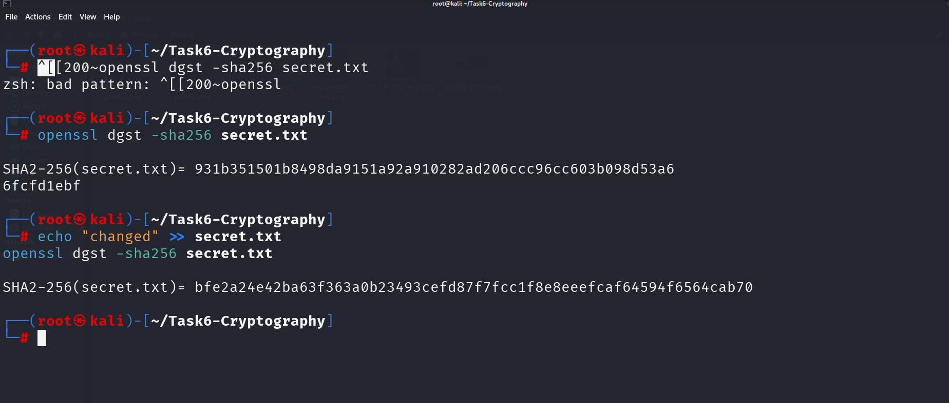
hash-changed.png

7. Digital Signatures
Digital signatures ensure:
- Authenticity
- Integrity
- Non-repudiation

Create Digital Signature
openssl dgst -sha256 -sign private.pem -out signature.bin secret.txt
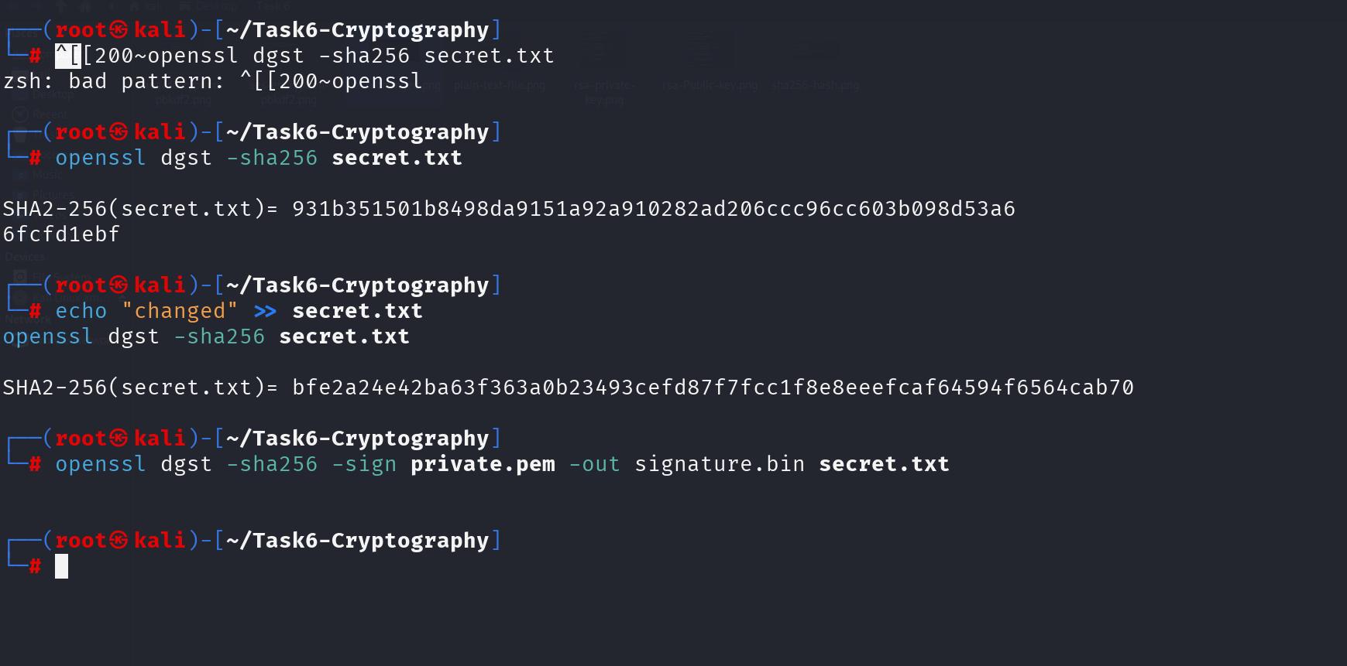
digital-sign.png

Verify Digital Signature
openssl dgst -sha256 -verify public.pem \
-signature signature.bin secret.txt
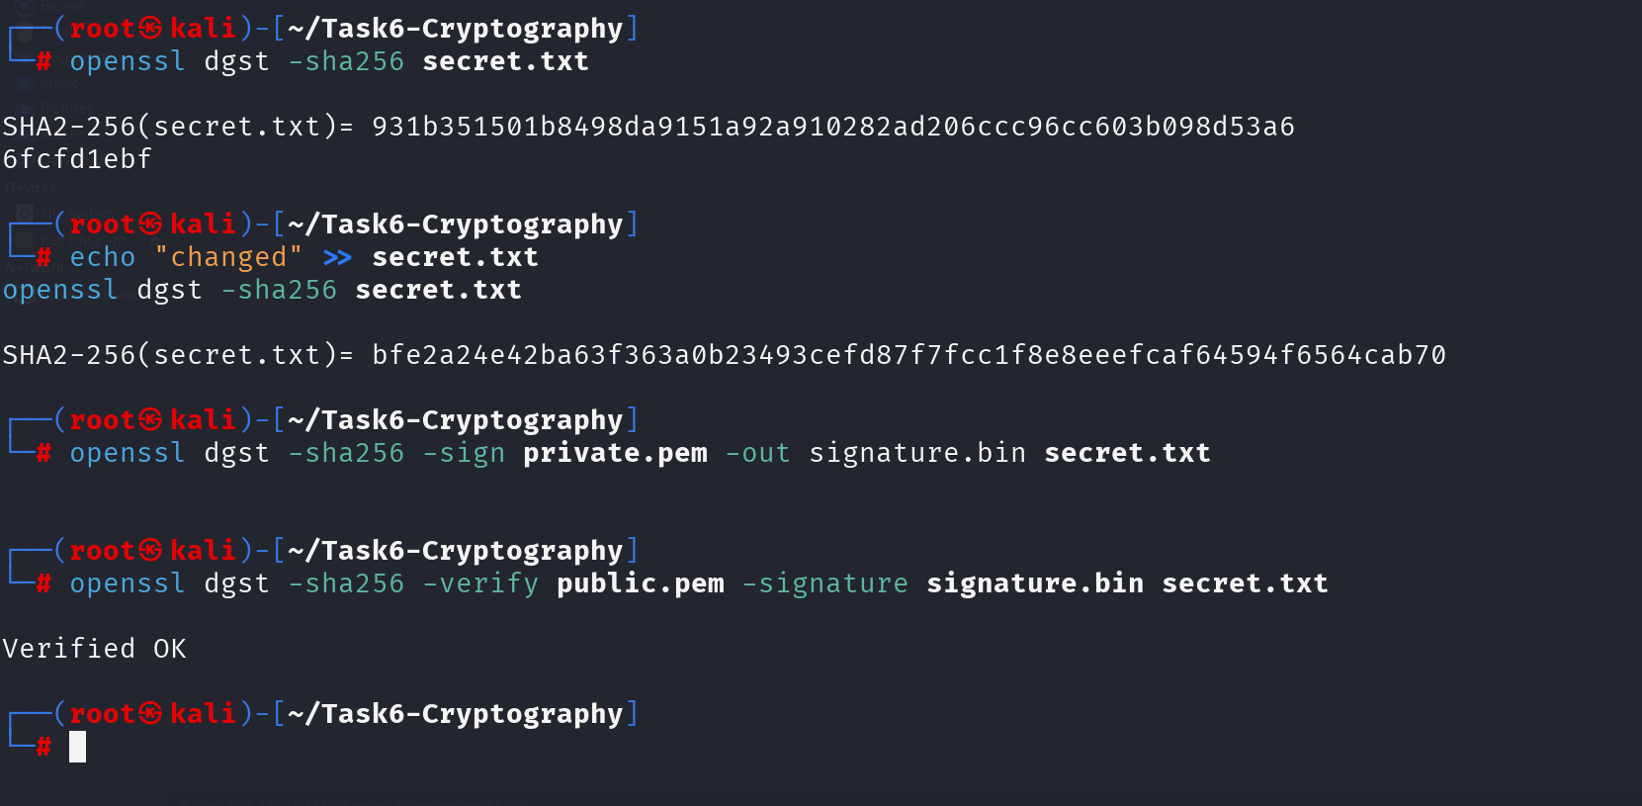
digital-verify.png
Successful verification confirms the file was not altered and was signed by the correct private key.

8. Comparison of Cryptographic Techniques
Technique | Purpose
AES | Fast data encryption
RSA | Secure key exchange
Hashing | Integrity verification
Digital Signature | Authentication and integrity

9. Real-World Applications
- HTTPS – Secure web communication
- VPN – Encrypted network tunnels
- SSH – Secure remote access
- Digital Certificates – Identity verification

10. Conclusion
This experiment provided hands-on understanding of cryptographic fundamentals.
By using AES encryption with PBKDF2, RSA key generation, hashing, and digital signatures, the task demonstrated how cryptography protects data confidentiality, integrity, and authenticity in real-world systems.

